**Introduction**

By now, you should be familiar with techniques for adding data to Microsoft Excel and managing worksheets. In this exercise, you’ll put these new skills into practice by working with an Excel file. You’ll improve the readability of the data by formatting it and making structural changes to the worksheet itself. By completing this exercise, you’ll prove that you have the skills to prepare a file for submission to a colleague or manager.

**Case study**

Renee, an Adventure Works executive based in the USA, has shared two files with you. The first is an Excel workbook called S*ample.xlsx.* The second is a PDF file called *Exchange Rates.pdf*. Your task is to add some data to the workbook file from the PDF and ensure it is correctly structured and formatted for readability.

**Excel User Interface**

In this course, we use the Microsoft 365 Desktop version of Excel. Microsoft 365 releases updates monthly, incorporating new features. You might experience changes in the Excel Desktop User Interface (UI) that have taken place after the development of this training content. As a result, the screenshots in the videos, readings, or exercises might not align precisely with how you experience the UI. However, please note that these changes do not impact the functionalities of the UI. Therefore, you will still be capable of performing all the steps demonstrated in the videos, readings, and exercises.

**Instructions**

**Step 1: Download and open the required files**

1. Download and open the Excel workbook *Sample.xlsx.* This workbook consists of a sheet called **Sheet1** that contains financial data. It also contains a sheet called **Contacts**, which you will use in another part of this exercise. A preview of **Sheet1** is visible in the screenshot. You will complete this exercise by adding data to and formatting, **Sheet1** in the workbook.

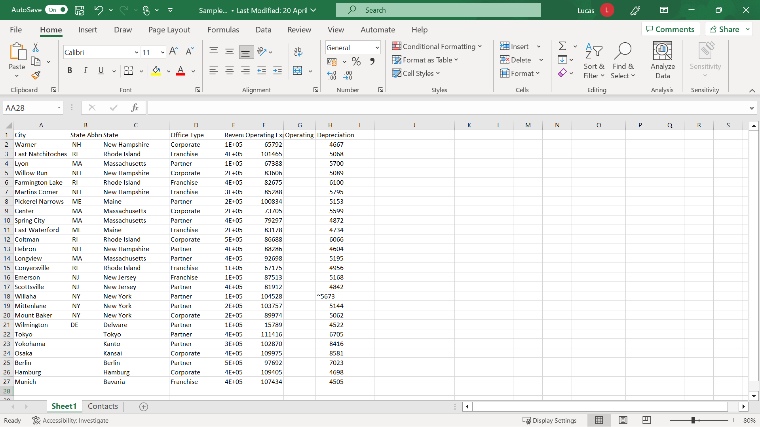

1. Next, download the *Exchange Rates.pdf* file. You will add the data from this PDF to your workbook. Save the PDF file in a location where you can quickly find it to use in Step 4.

**Step 2: Verify and correct the existing information in the sheet**

To begin, open **Sheet1** in the *Sample* Excel file, then carry out the following tasks:

1. The **State Abbreviation** column is unnecessary and can be deleted because the sheet contains international data. Select column **B**, then right-click and select **Delete Columns** from the shortcut menu.
2. The entries in column **D** appear different than the other columns. This is because the column is too narrow. Position the mouse pointer on the vertical line between the **D** and **E** column identifiers, then double-click to resize the column automatically.
3. The figures in the spreadsheet will be a key focus of the meeting, so you need to confirm that there are no other issues in the number range. The number in cell **G18** is sitting over to the left of the cell, which indicates that Excel is treating the entry as text. The ~ character at the beginning of the entry is causing the problem, causing the entry to be auto-detected as text. Double-click on cell **G18** to enter **Edit mode**. Then move the cursor to the right of the character and press **backspace**. Press **Enter** to confirm the amendment and correctly realign the entry.
4. Add a column to hold country data to display the worksheet’s international financial data. Add this new column to the right of the **State** column and fill in the country entries. Select the letter **C** that identifies the column to select it. Then right-click and choose **Insert Columns** from the shortcut menu. A new blank column appears to the left of the column titled **Office Type**.
5. Type the heading **Country** in **C1** and then **USA** in **C2**. Move the cursor back to **C2**, then hover the mouse pointer over the bottom right-hand corner until it becomes the narrow black cross. Hold down the mouse button and drag it down as far as row **21** to copy the entry quickly into the appropriate cells. Add **Japan** to **C22** and use a similar **Autofill** technique to complete the country entries in rows **23** and **24**. Add **Germany** to **C25** and use a similar **Autofill** technique to complete the country entries in rows **26** and **27**.
6. Renee would like the information relating to Japan and Germany to be easily identifiable. So, she has asked you to add these country names as headings above both sets of information to create a clearer distinction between the data for these countries and the USA. First, select row **22** on the left-hand side. Then right-click and choose **Insert Rows** from the shortcut menu. Select row **26** and repeat the insert rows operation. Then type **Japan** in cell **A22** and **Germany** in **A26**.

**Step 3: Format the data**

The worksheet now contains all the required information. Your next step is to improve its readability before presenting it to management.

1. First, you need to emphasize the titles in row 1. Select the range of cells **A1 to H1**, and on the **Home** tab, select the **Font** group. Then choose **font size 14** and a different background color. Without canceling the selection, center the headings. On the **Home** tab, select the **Alignment** group, then select the **Center** choice.
2. The heading **Revenue** in **E1** and the **Depreciation** heading in **H** are only partially visible, as the columns are not wide enough to accommodate the text. Double-click on the vertical separator between **E** and **F** to automatically resize column **E.** Then perform a similar adjustment on column **H.**
3. The titles in **F1** and **G1** are also exhibiting visibility issues. However, widening the columns would create too much visible white space. Instead, select **F1** and **G1.** On the **Home** tab, select the **Alignment group,** then choose **Wrap Text.**
4. Column **G** still needs to be a little wider. So, hover the mouse pointer over the dividing line between the column letters **G** and **H**, hold down the mouse button, and drag it slightly to the right.
5. The headings in the first row now stand out and are easier to read. You now need to emphasize the country headings in **A22** and **A26**. Move the cursor to **A1.** On the **Home** tab, in the **Clipboard** group, select the **Format Painter** button and then select **A22**. Repeat the process for **A26**. Next, select cells **B22** to **H22** and apply the same background color. Repeat this process for cells **B26** to **H26**.
6. Next, you need to add currency formats to distinguish between the three currencies in the sheet. Select cells **E2** to **H21.** On the **Home tab** in the **Number** group, select the **currency drop-down** and then choose the **dollar** symbol. However, this action generates extra characters and decimal places. So, column **F** needs to be resized a little.
7. Select cells **E27** to **H29** and choose the **Euro** currency format from the **Currency** drop-down.
8. Finally, select cells **E23** to **H25** and select the **Currency** drop-down again. There is no Japanese Yen choice offered in the immediate list. Select the **More Accounting Formats** choice at the bottom. Select the **Currency category** on the left of the number format dialog. Choose **¥ Japanese** (also known as Japanese Yen) from the **Symbol** drop-down on the right.

**Step 4: Add new information to the workbook**

Now that you’ve improved the formatting and readability of the data in **Sheet 1**, you need to add the information from the *Exchange Rates.pdf* file to the Microsoft Excel workbook.

1. The information on exchange rates needs to be in the Excel file but held separately from the data you have just been working on. Create a new worksheet by selecting the **+** symbol in the worksheet **tab** area.
2. In cell **A1** of the new sheet, type the heading **USD Amount.** In cell **B1,** type the heading **Currency**. In cell **C1** type the heading **Rate**. In **A2**, type the number **1***,* and in **B2** type **Yen**. In **A3**, type the number **1**, and in **B3** type **Euro**. Then, in **C2** and **C3**, add the appropriate exchange rate figures from the PDF.
3. To provide visual consistency between both sheets, format these headings to match the headings in **Sheet1**.

**Step 5: Manage the worksheets**

The workbook is now almost complete. In the last few steps, you must name and organize the worksheets you need for the presentation.

1. The original worksheet that you edited is still called **Sheet1**. The sheet you added to hold the exchange rate information will also have a generic title of **Sheet** followed by a number. Both titles could be more descriptive. So, rename the first sheet **Sample Figures**, and the other sheet **Exchange Rates***.* Right-click the relevant **sheet tab**, type the new names, and select **OK**.
2. To prepare for your presentation, it is best to position the **Exchange Rates** sheet to the right of the **Sample Figures** sheet. Point your cursor at the **Exchange Rates** tab, hold down the mouse button, and drag it to its new position.
3. You don’t yet have all the required data for the **Contacts** sheet. In addition, this sheet is not directly relevant to your presentation. However, the information will be needed in the future. Rather than deleting it, you can hide it for the duration of the presentation. Select the **sheet**. On the **Home** tab in the **Cells** group,choose **Format** and then select **Hide & Unhide** to hide the sheet.